Wellington Garbage Incinerator

Jihui Lee, Jewon Moon, Abdulaziz

English School of Canada (UCTP)

Edward Newton

**Introduction**

The world we live in has polluted by different factors such as, factories. Factories can play significant role in polluted the air. The reason why factories can effect weather that factories release emission this emission can affect the weather and can destroy the environment.

**Brownfield definition**

Real property, the expansion, redevelopment, or reuse of which may be the complicated by the presence or potential presence of a hazardous substance, pollutant, or contaminant. Usually abandoned, closed or under-used industrial or commercial facilities, such as an abandoned factory in a town. In different words old building that can affect the environment (harmful to the environment) government abandoned these buildings and change it to sustainable building.

**Sustainability definition**

Sustainability isthe ability to maintain a certain status or process in existing system. In other words, sustainability can be defend to do or change something to be friendly with the environment not necessary to be just for building human being can sustain themselves.

**Location:**

It is located at 677 Wellington Street West, ON M5V 1G8 (Appendix 1). This location was chosen for two reasons. First, it is near to St Andrew subway station, the distance from the school to St Andrew station nine minutes, six minutes by bus and three minutes by walking. Second, the school located at downtown, which means easy for people in order to get there. The original function for the factory was garbage incinerator but the group is going to change this factory to English school and make it sustainable as much as possible. The Wellington Destructor was constructed in 1925 in Toronto's Liberty Village. It was one of several local incinerators responsible for decades of immense and repulsive levels of air pollution.

**Sustainability break to for parts:**

* **Human:** In terms of human it is a factor that can affect the environment in good way or bad way. People should be aware of sustainability to help the environment. Awareness is important for human being to teach their children how to sustain themselves.
* **Economic:** Economic plays a big role in sustainability the reason for that usually sustainable products kind of expensive.
* **Social:** In simple terms, communities and civil societies can play significant role with reference to have the ability to work together in order to get along.
* **Environmental**: People have to save the environment by increase the trees. The reason why because if people did not work on saving the environment, the weather is going to be polluted. For example, if people use wood too much this can affect the environment. In fact, People cut hundreds of trees and plants. Moreover, People will go back to implant the half of them. Because of that, they are going to face the desertification, which there will be no trees any more.

**Methodology**

**Ⅰ. Sustainable site design**

**1. Walkways and conifer garden**

Our building area was a waste disposal site. Therefore, surrounding environment was not clean, and there was not anything before creating the our building. Accordingly, walkways and garden will be designed to be environmentally. First, walkways are made of pervious concrete which allows water penetration because it has less effects in environment than the other materials. second, conifer garden will be made near walkway because conifer can adapt to the extreme weather which is intensely cold in Canada and it is helpful to maintain the condition of the soil.

**2. Parking area**

Our building need to make bicycle and car parking place because it is far from mass transit. However, car parking place should be built small, and we will encourage riding bicycle for reducing car emission. In addition, bicycle rental shop will be operated in the building for teachers and students. For that reasons, bicycle parking place and bicycle rental shop will be big enough. Moreover, we will have car-pooling program and shuttle bus for students and teachers. Car-pooling program can help to reduce car usage because people who live same neighborhood can come to our building together with a car, and a free shuttle bus is also run every half hour for students and teachers from subway station to building. It can help to come to building easily, and reduce using energy.

**Ⅱ. Materials and Resources**

**1. Glass wall**

South wall of our building will be made of glass because it has a lot of advantages. It can reduce using light, air conditioner, and heating system. Moreover, we will use glass wall with dot screen. Dot screen can prevent the sun's heat, but daylight can pass through the glass. Therefore, inside will be kept bright and maintained proper temperature by using glass wall.

**2. Pervious concrete**

Pervious concrete allows water penetration (Appendix 2). Therefore, it can help recharging groundwater and reducing storm water runoff. Furthermore, Pervious concrete is durable, low maintenance, and has a low life cycle cost. For that reasons, pervious concrete is used in our parking place, paving and walkways.

**3. Bright color sustainable paint**

Typical paint contains toxic ingredients and strong smell whereas eco-friendly paint is biodegradable, non-toxic, and odorless. Thus, green sustainable paint will be used on the wall of our building. In addition, paint color should be bright because a dark color cannot reflect sunlight and absorb the heat. It is caused to increase indoor temperature. Therefore, it can be helpful to reduce using air conditioner and light energy.

**Ⅲ. Indoor Environmental Quality**

**1. Ventilator**

Ventilation is important because it can properly maintain fresh air and temperature for health (Appendix 3). Ventilator helps naturally recycling air and maintain low temperature in summer. Therefore, ventilator will be installed on the roof. Moreover, our ventilator does not have motor, and it will work by only natural wind, so it will influence positive effects in environment.

**2. Windows design**

Window design is the most important when indoor design because it makes building can be reduced using air conditioner, heating and light. When we allocate window in our building, window should be on the south side than the other side especially east and west due to direct light and ultraviolet rays. Moreover, our building has many big windows because it helps to be well ventilated. Our building is located near Lake Ontario. Therefore, there are a lot of wind so our building does not need to use air conditioner a lot.

**Ⅳ. Water Quality and Conservation**

**1. Rainwater tank**

Rainwater tank is devices for collecting and maintaining rain. It is installed to make use of rainwater for gardening and using washroom in our building. Thus, pipe will be installed on the roof of our building and collects rainwater in rainwater tank. It can helpful to save water and reduce energy.

**2. Washroom infrared sensor tap**

Waste water can be reduced by using an infrared sensor tap in washroom. An infrared sensor detects hand and body movements and automatically starts water flow. Thus, infrared sensor tap will be installed in washbasin and toilet of washroom, and it will be worked by solar panel energy. Therefore, It can prevent waste of water and save energy.

**Ⅴ. Energy and Environment**

**1. Solar panel**

Is a device that receive sunlight then convert it to energy in order to use it for the building (Appendix 4). The solar panel is going to reduce using energy and the cost for the purpose of electricity. Solar panels it needs to be connected with the main electricity supply when solar panels receive sun’s energy and change it to power electricity (Appendix 4). Solar panels it will install on the roof of the building and it will connected to the main electricity meter, And this will reduce the use of energy.

**2. Lighting system**

The school need to have an excellent lighting system to make students comfortable on the occasion of they are in the classes. The school is going in order to depend on daily sunlight this building is going to have windows in all the classes are going to have at least one window, which can make easy access to the light to go inside the building. The school is going to create lighting system with sensors Philips Hue Personal Wireless Lighting. This system is going to have solar panels on the roof. Solar panel: is a device that receive sunlight then convert it to energy in order to use it for the building. The solar panel is going to reduce using energy and the cost for the purpose of electricity. In terms of lighting system this system has so many benefits. Also, it can be controlled by means of phone, this system of light lives with reference to long life 15.000 hours or 14 years, the system has the ability to change the light color. In fact, this system can be controlled not only from short distance but also from long distance, also, the system can save energy for up to 80%. In the morning, the school is going to depend on the sunlight and at night, the light is going to work in light of fact that solar panels have, which can save some energy. So, the system will reduce the use of energy and the cost for using it at the same time.

**Results**

**Ⅰ. Environmental**

The wellington garbage incinerator (Appendix 5) is now empty place with huge amount of garbage. It was built in 1925 the massive garbage facility and its three towering smokestacks were a fixture of Toronto’s 20th-century skyline. The incinerator remained in operation until the 1960s, after the city switched to storing trash in landfills. There is no way to dispose of the rubbish which cannot recycle like plastic, leather, metal and paper. Fortunately, food waste can convert into fertilizer. However, the existence of incinerator is one of the growing environmental worldwide issues. Human activities generate enormous garbage so that people need incinerator. However, it is not good for environment. Furthermore, if the place leaves more, it can cause countless contamination including air, water and soil pollution. The language school will use good components for the nature. First, it can save water by reusing water through rainwater tank. Second, the school will use pervious parking surface which is the same way of EVERGREEN BRICK WORKS. The system prevents from flood via pervious surface which absorbing water. Lastly, the company implements carpooling system. It reduces the amount of exhaust gas of automobile. It is related air contamination directly. These three factors have positive effect toward environment.

**Ⅱ. Economic**

The incinerator is empty place so that if revitalize the site, it can make a profit through various factors. These days, other languages are one of the most beneficial strengths in society. Learning language make broaden perspective especially, studying abroad. Many more young students go abroad for language training. Despite they can learn in their own country, student want to be surrounded by speaking other language. The ratio of going abroad is increasing from year to year. They spend money in this place for tuition fee and additional things. It helps with foreign exchange earnings. The language school is also located in downtown so that accessible place for students. The condition will gather many more students. Using solar panel reduces electronic cost which the same way of the EVERGREEN BRICK WORKS. For long-term effect, the school will install glass wall with dot screen. All things need initial facility cost, but it can save money to see long-term.

**Ⅲ. Human**

**1. Child rearing**

By changing the purpose of the place which is language school, it brings individual benefit from learning language. Children should have enough skills and knowledge such that they can sustain their own way of life. Therefore, people become more educated and it can lead to the high quality of life. Learning language is one of the important upbringing factors in modern society. In era of globalization, new language is one of the competitive advantages for everyone.

**2. Child bearing**

The fundamental need of human is safe childbearing and good reproductive health. At this point, incinerator with massive garbage creates polluted acid rain. Acid rain can cause health problems in people. It can cause respiratory diseases, or can make these diseases worse. Respiratory diseases like asthma or chronic bronchitis make it hard for people to breathe. The polluted acid rain can also create tiny particles. When these particles get into people's lungs, they can cause health problem. Children are the most vulnerable to acid rain. The harmful side effects of acid rain is not only seen when we are in direct contact with it, but also in indirect contact. For example, fruits and vegetable that come in contact with this type of rain can also harm our body in the same way. As a result, removing incinerator can prevent from these problems.

**Ⅳ. Social**

Through this language school, people can become more open-minded toward other people and get various perspectives. The skill of communication makes people more sociable. The place will be meeting point which gathering people from different countries. They all can get multicultural experiences such as other country's culture. The school also provides diverse activities for students. People can gain international friendship.

**Discussion**

There are some limitations of being truly sustainable. Firstly, the place now needs to be revitalized. However, at first, we have to treat a huge amount of garbage. It takes a lot of money and time to move other place to burn it. Furthermore, the building was not working so that we need more money for construction. Secondly, we use a lot of things which is sustainable to build.

For the long term, it can save much energy and money. However, it can be drawback for us. The all system can operate under the huge capital stock. Thirdly, accessibility of building and surrounding area is not convenient. Our building's location is far from subway station and street car. Therefore, we have to have shuttle bus and bicycle rental shop for students and teachers because of this problem. Moreover, our building's surrounding area is not convenient because there are nothing near our building. Thus, we should make more convenience such as convenient store. Lastly, solar panels has benefit of using it, reduce the cost, and reduce the use of energy. However, there is a problem is going to face solar panels in the winter, the snow can cover solar panels from receiving sunlight, but in this situation our teamwork will use salt to melt the snow.

**References**

Sustainable Window Design. (n.d). *Green Garage*. Retrieved from

http://www.greengaragedetroit.com/index.php?title=Sustainable_Window_Design

Christopher C. (2012 April, 24). Green Sustainable Paint Solutions. *Buildings*.

Retrieved from http://www.buildings.com/article-details/articleid/14433/title/green- sustainable-paint-solutions.aspx

Sustainable Buildings. (n.d). *AGC Glass Europe*. Retrieved from

http://www.agc-glass.eu/English/Homepage/Our- Values/Environment/Environmental- Report-2013/Sustainable-Buildings/page.aspx/2469

The Opportunity: Green Infrastructure. (n.d). *Project15206*. Retrieved from

http://www.project15206.org/opportunity/

How does acid rain affect humans? (2010 July, 19). *ACID RAIN*. Retrieved from

http://worldacidrainsecrets.blogspot.ca/2010/07/how-does-acid-rain-affect-humans.html

How Solar Panels Work. (n.d). *National SOLAR PV*. Retrieved from

http://nationalsolarpv.ngtrader.co.uk/solarpanels.htm

**Appendix 1**

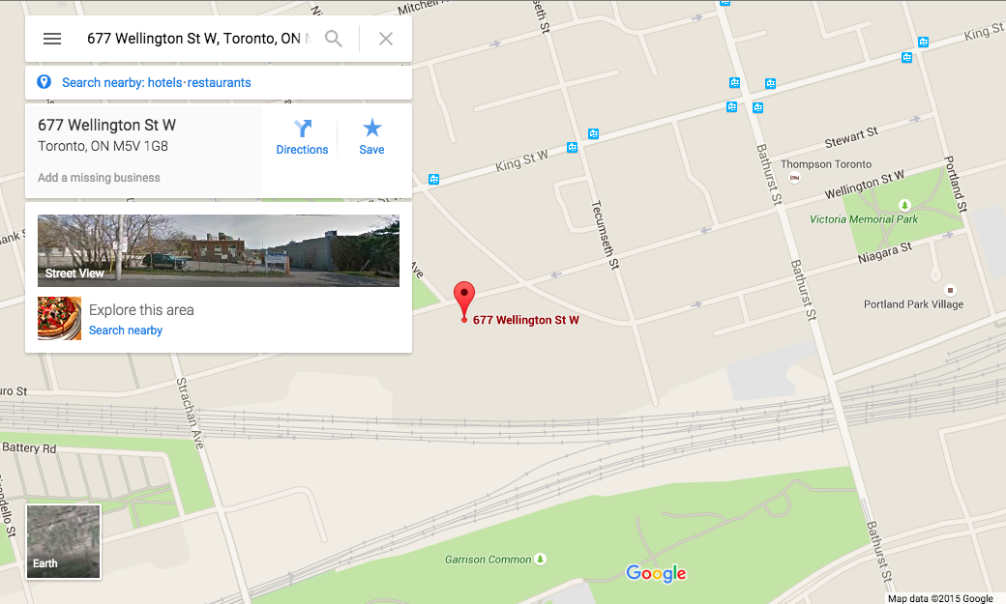

This is location of our building.

**Appendix 2**

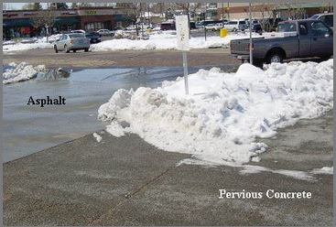

This is picture that it compare between pervious concrete and asphalt.

**Appendix 3**

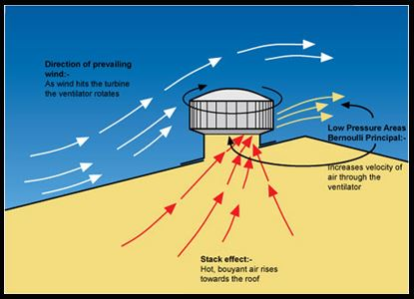

This is ventilator.

**Appendix 4**

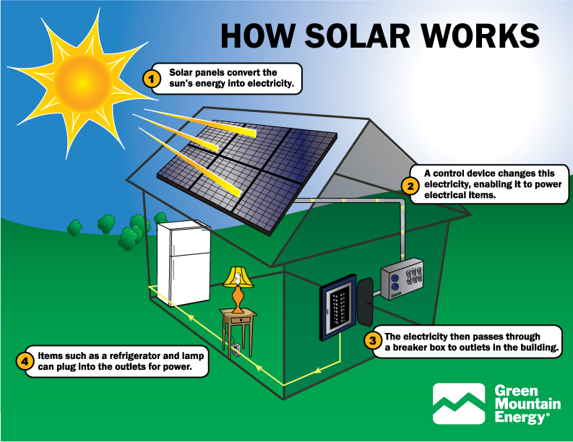

This is how to work solar panel.

**Appendix 5**

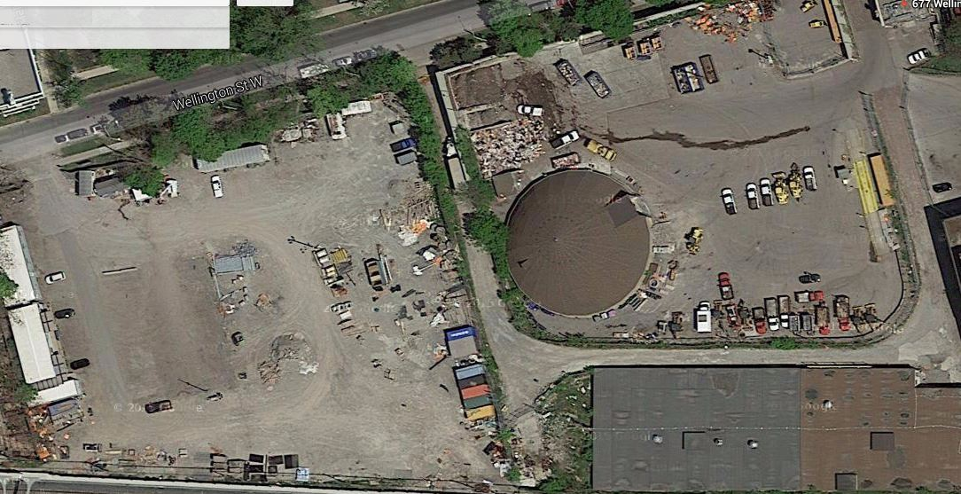

This is previous state of building.

**Appendix 6**

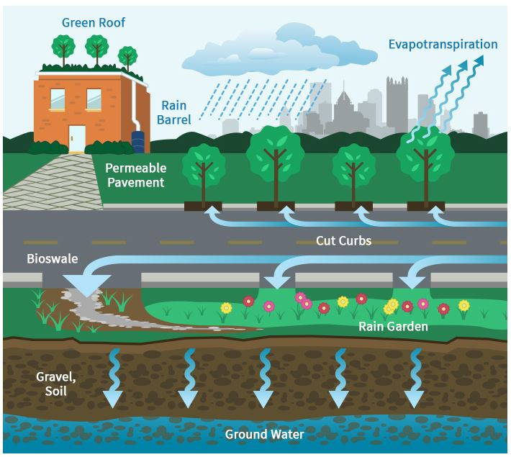

This is process of natural cycling.